Tab 1

**1. HOW TO CREATE AN IAM USER**

1. For creating an IAM user, login with the root account and you shall screen similar to the following

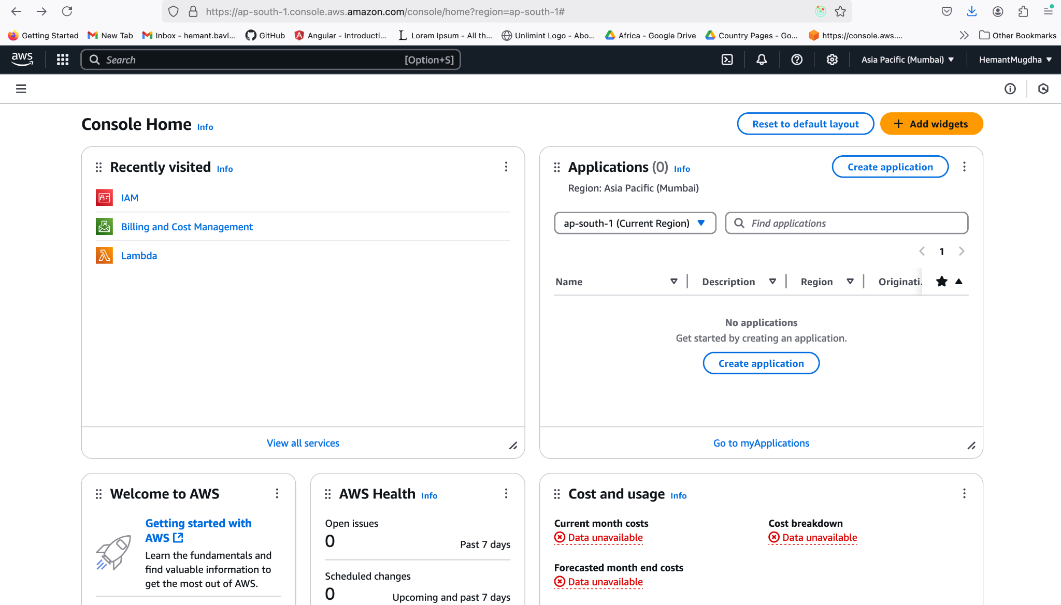

1. Type IAM in search bar or click on IAM from recently visited item list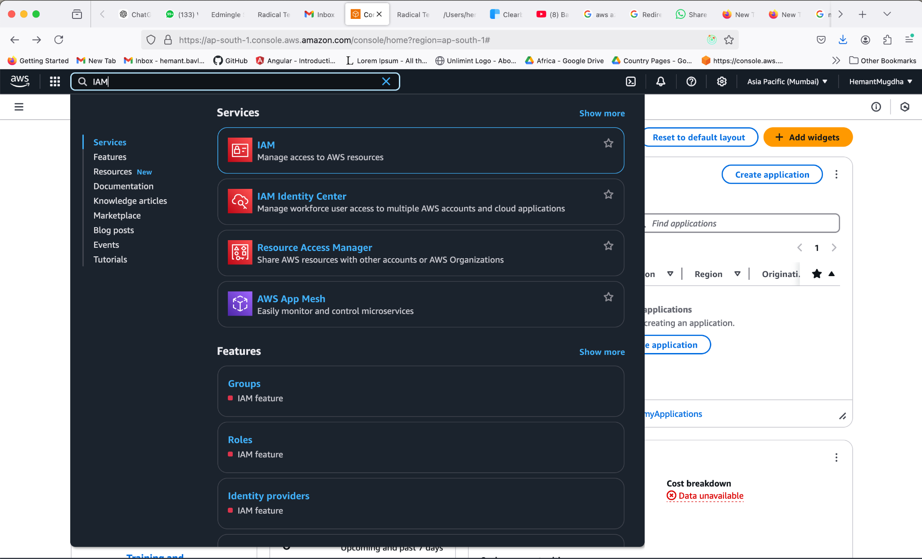
2. Click on IAM > Users, You will land on the following screen. Click on Create user button on the right 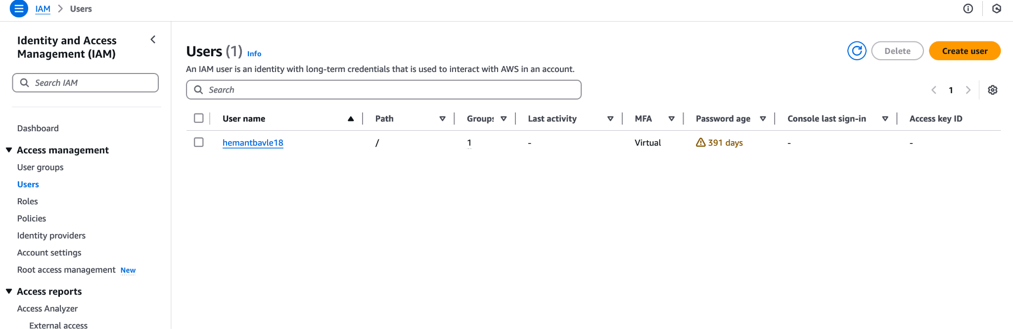
3. Add details for the user and click next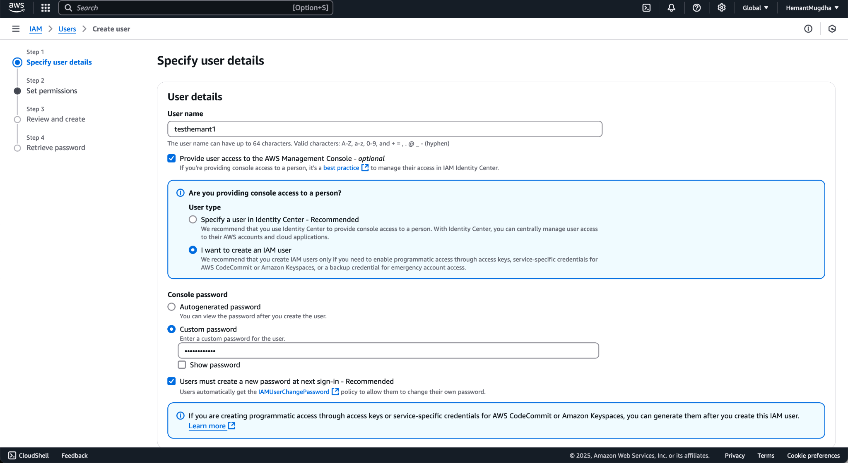
4. You can assign permission in 3 ways to the user:
   1. Using a user group as shown in the screenshot below

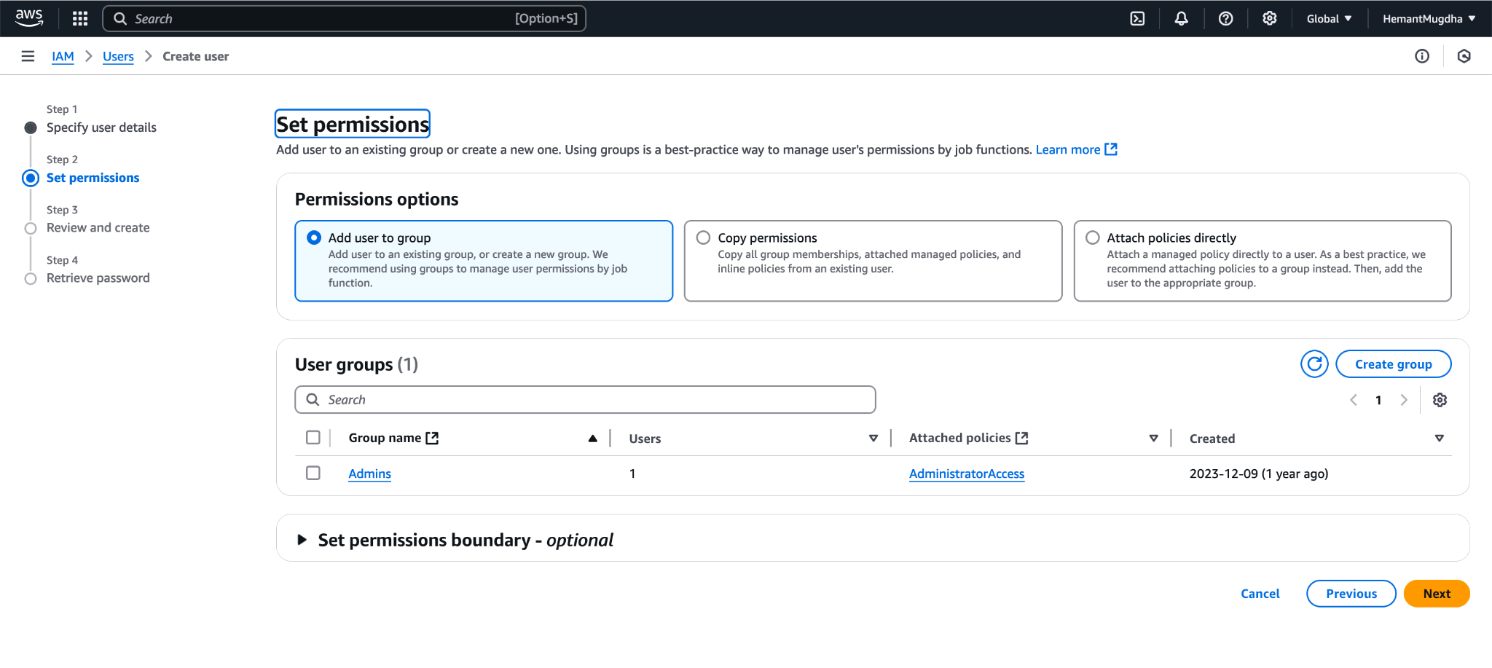

* 1. By copying permission from other users

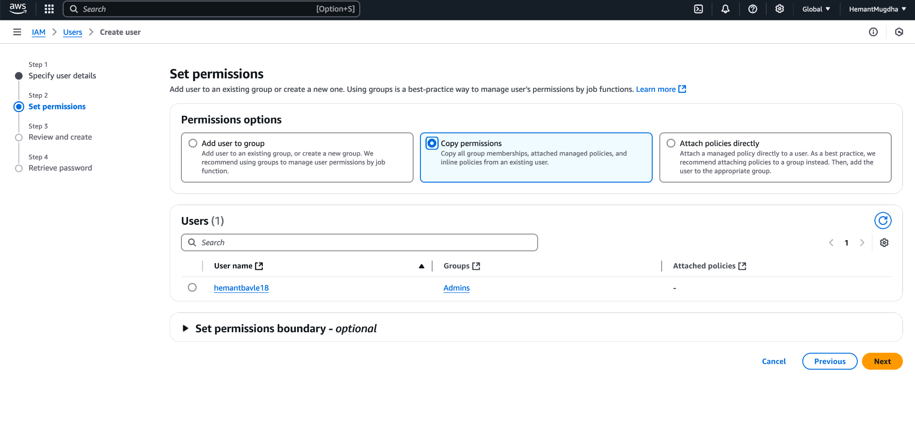c

* 1. By Attaching default policy directly to the user

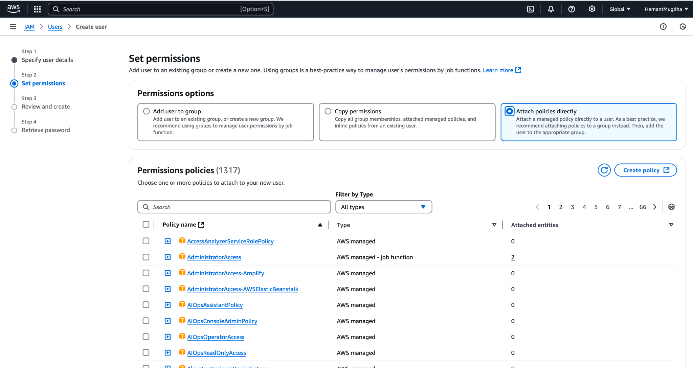

Click Next after you have used the appropriate option.

1. I created a new group with EC2 full access policy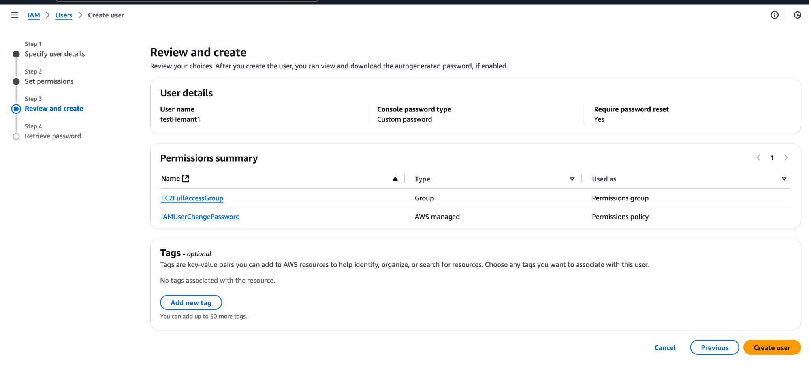
2. On clicking Create user button, a loader will show up and then a screen like below should show up.

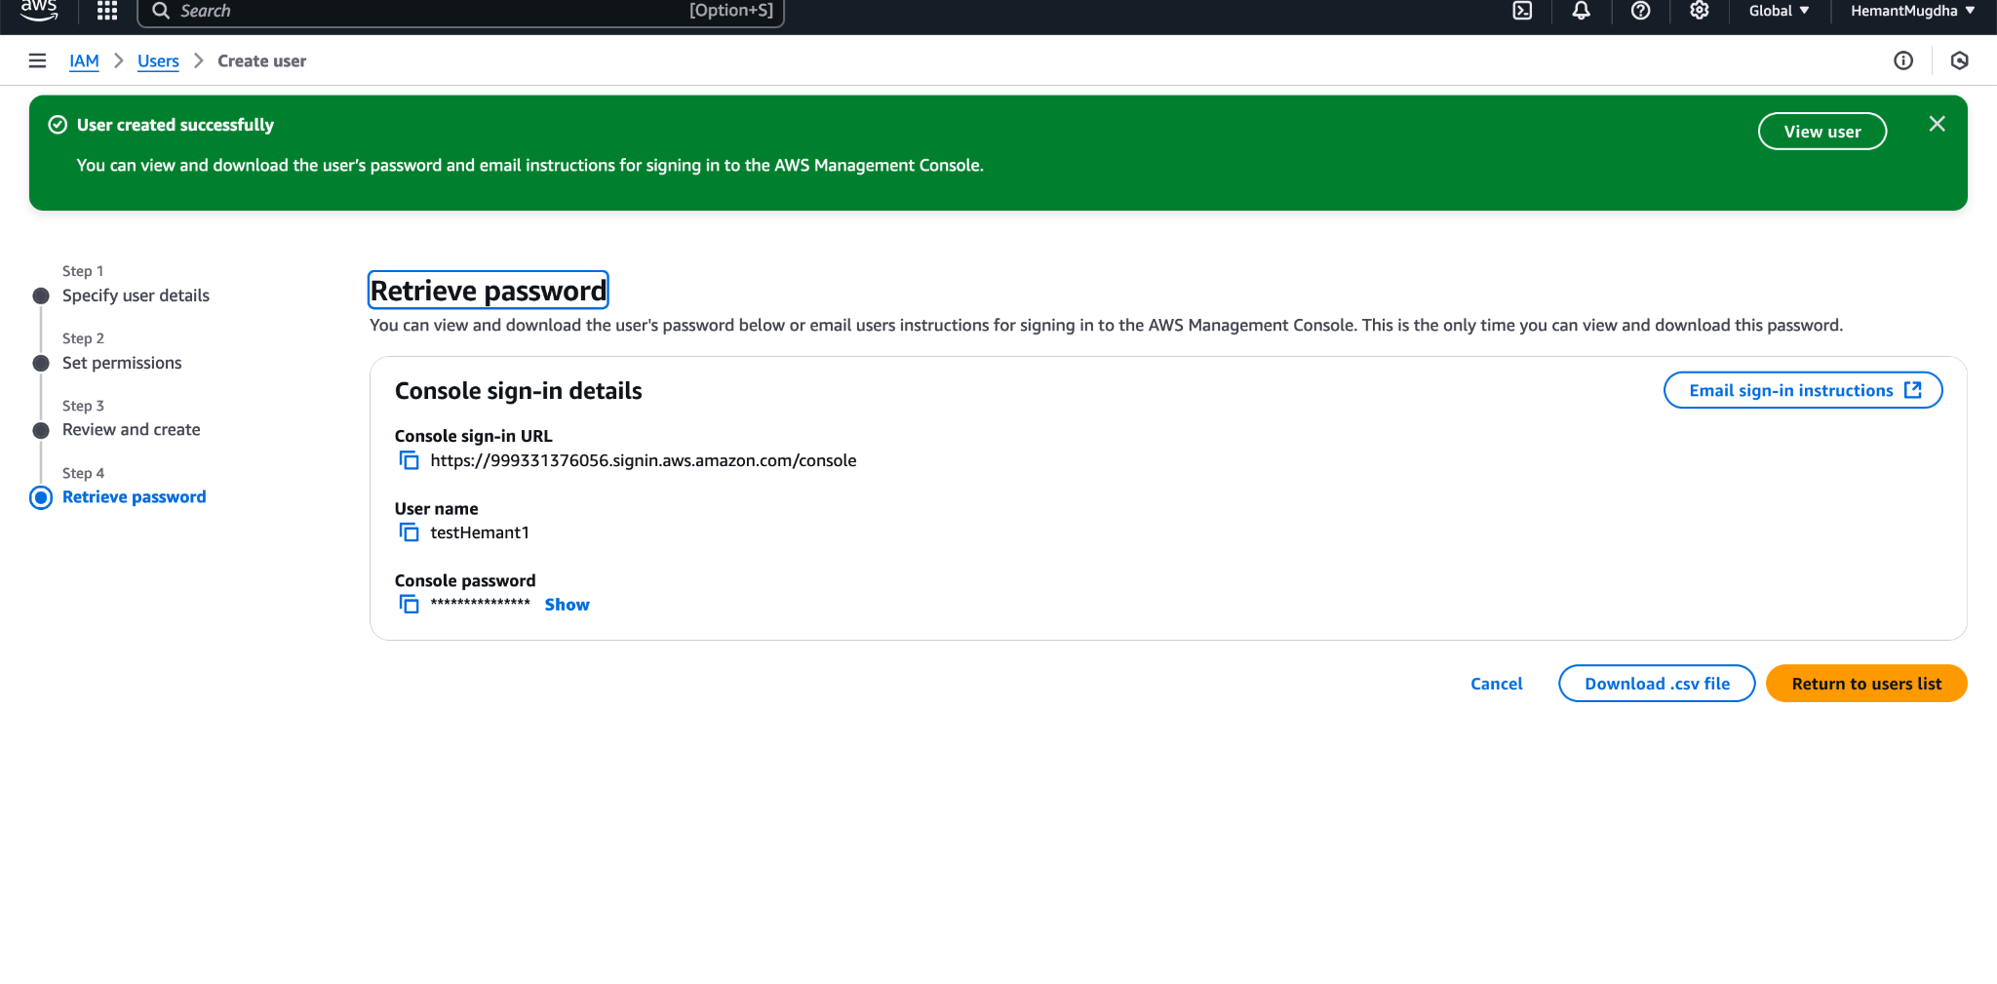

**2. Creating an EC2 Instance**

1. Login to your aws account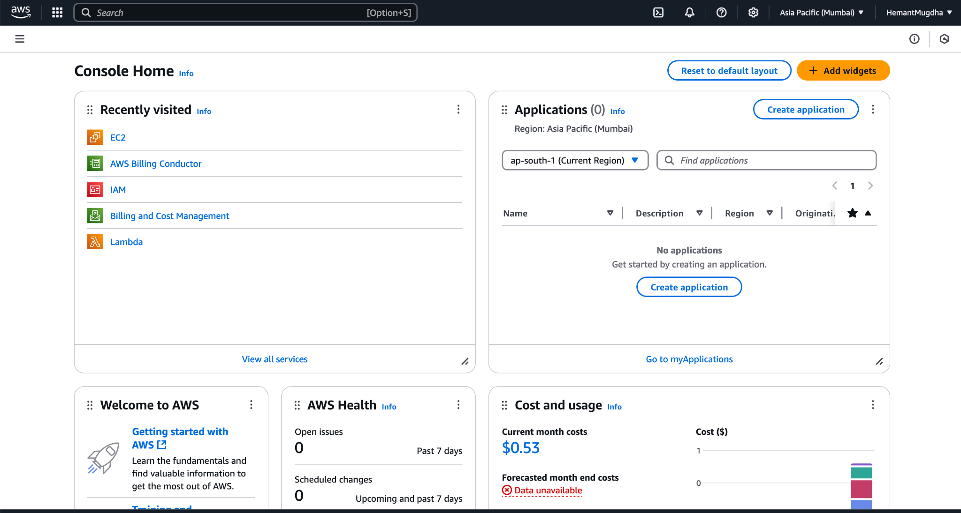
2. In the search bar type, EC2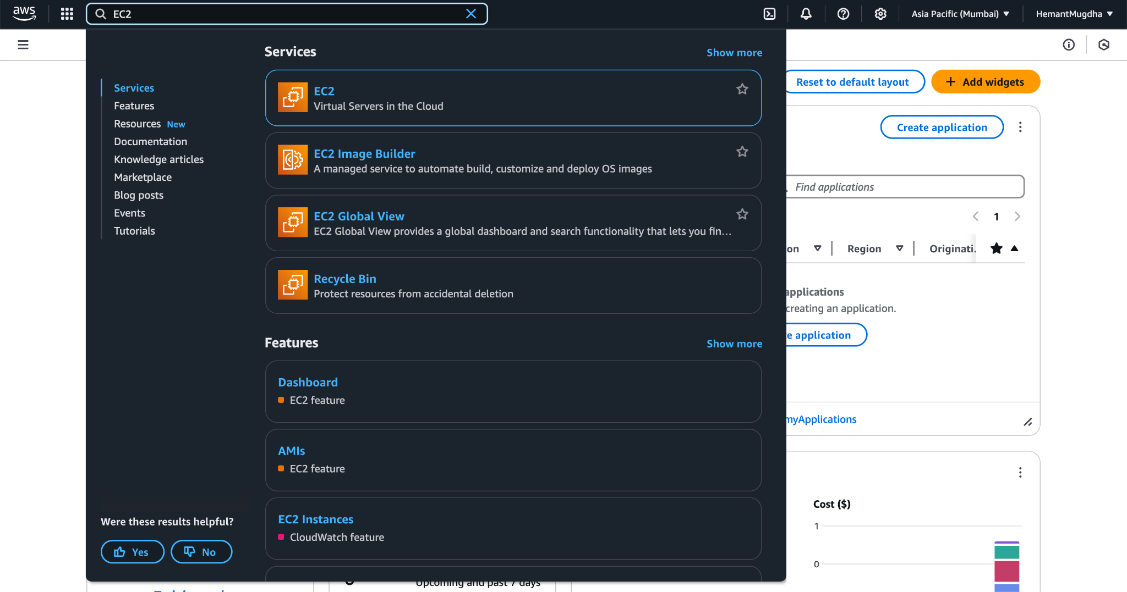
3. Click to EC2 to open EC2 Home page as shown below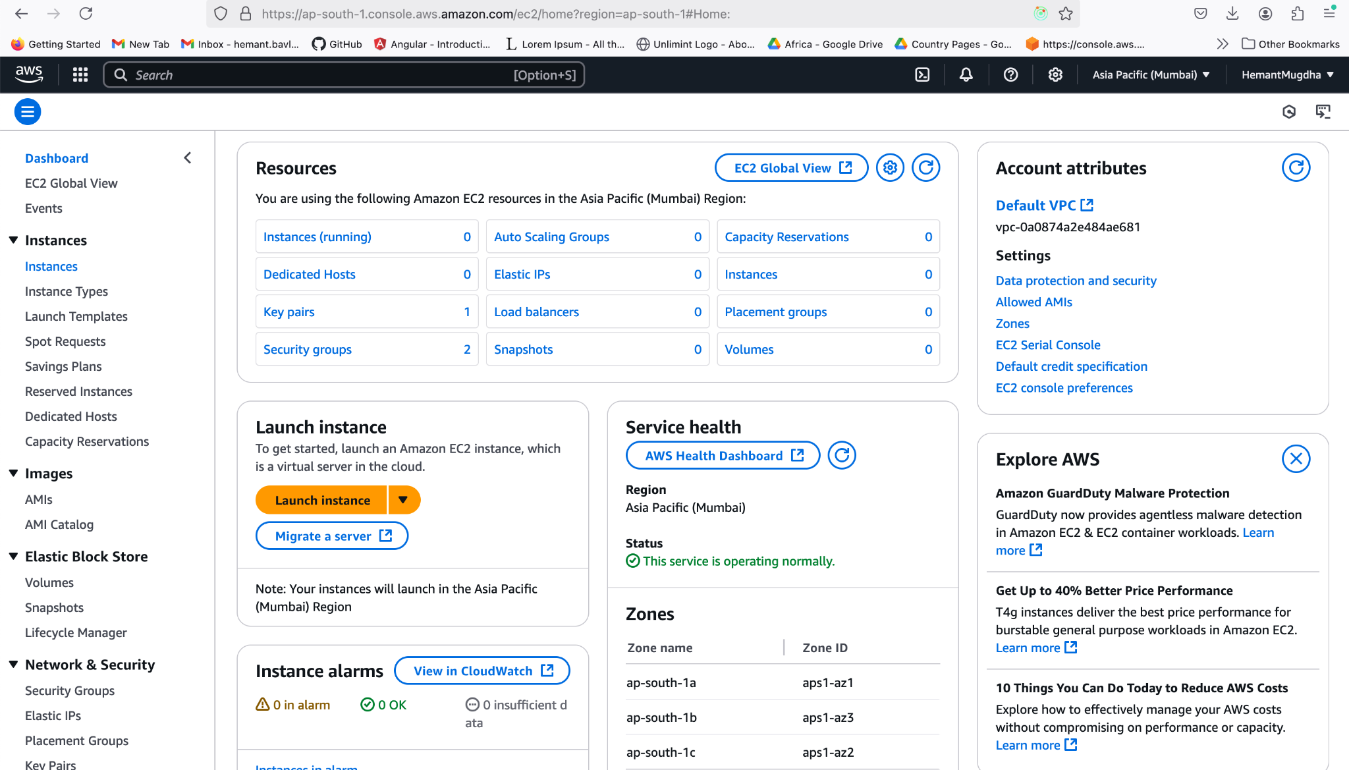
4. From the left hand menu, click on Instances, it will open a list of instances(show instances if they do exist else an empty list like below is shown)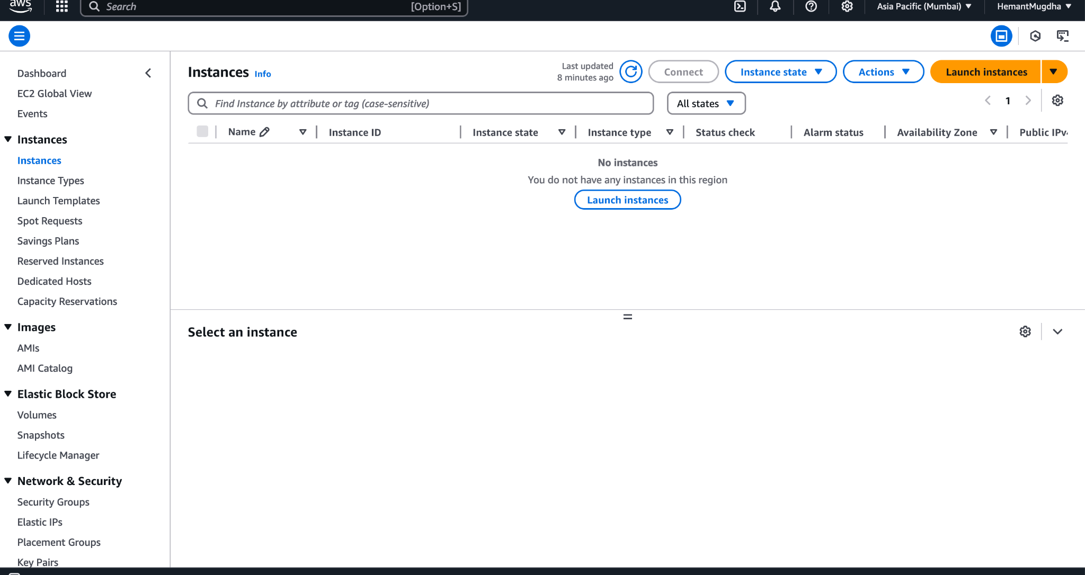
5. Click on Launch Instances and Add name > Select OS Image from Amazon Machine Image section

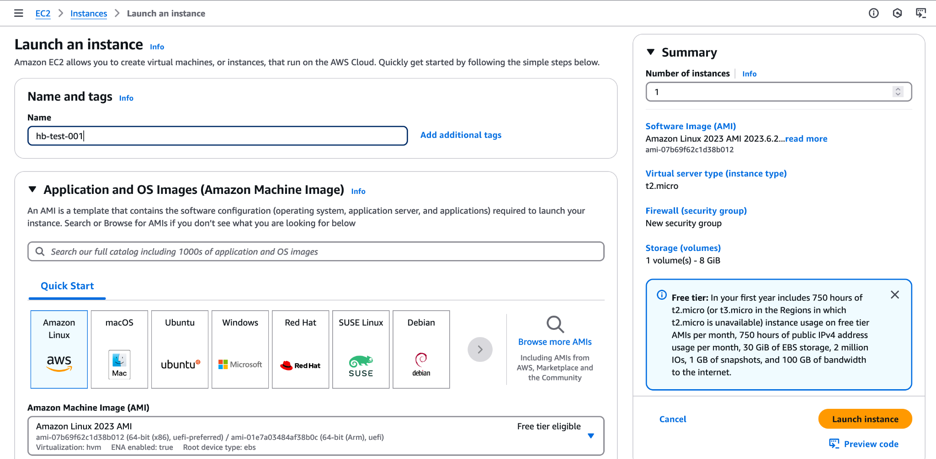

1. Scroll down > In Key pair section > Click Create new key pair > Add details in modal > click add key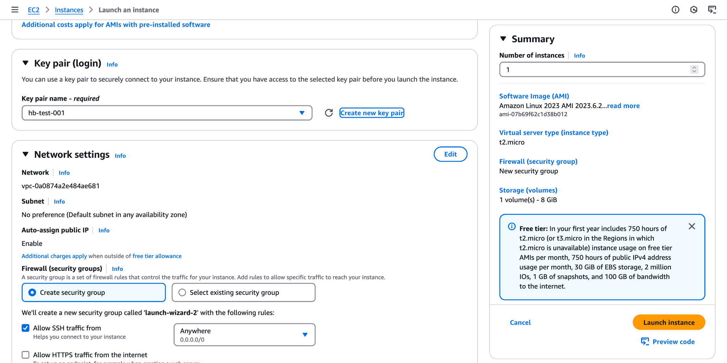

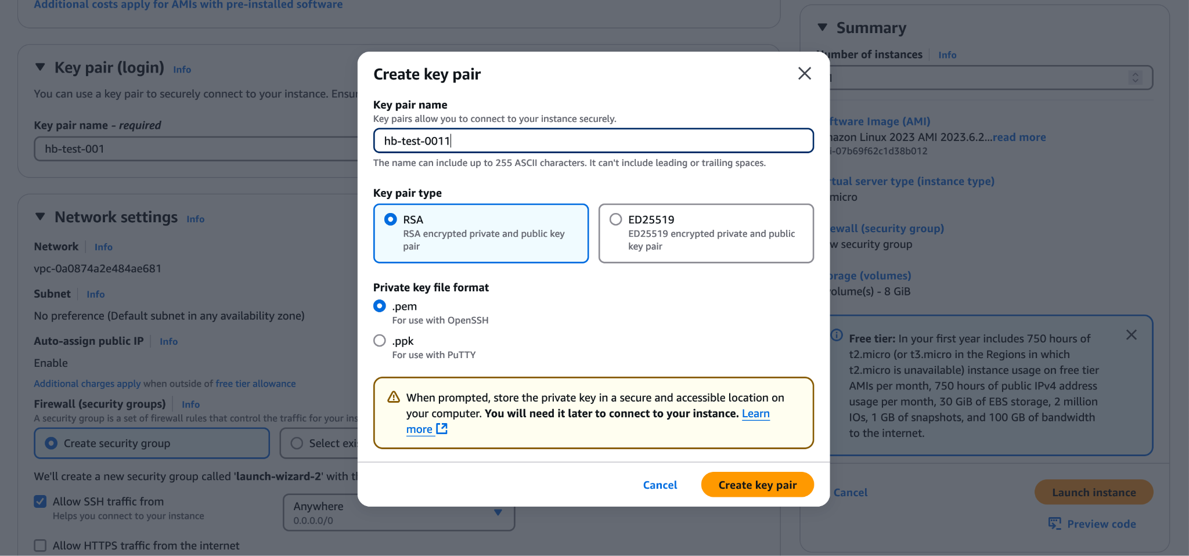

1. After creating the key pair, **download it and save it in a folder.**
2. After creating the key pair, click on launch instance as shown below
3. After clicking launch instance you can see the following screen. This means the instance has been created.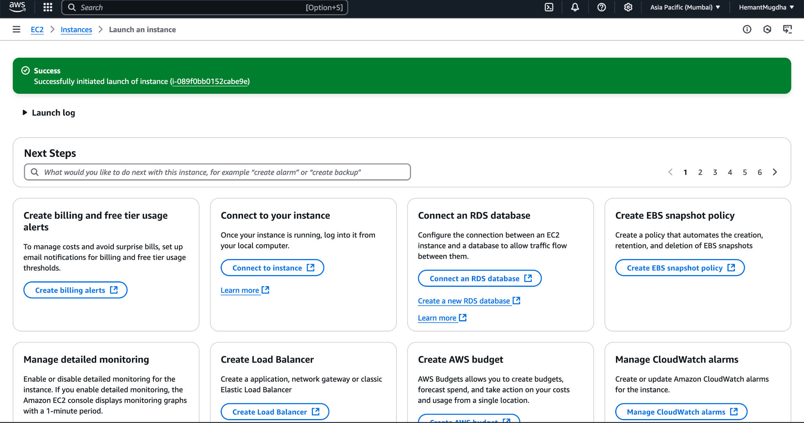
4. The screen below shows the created instance.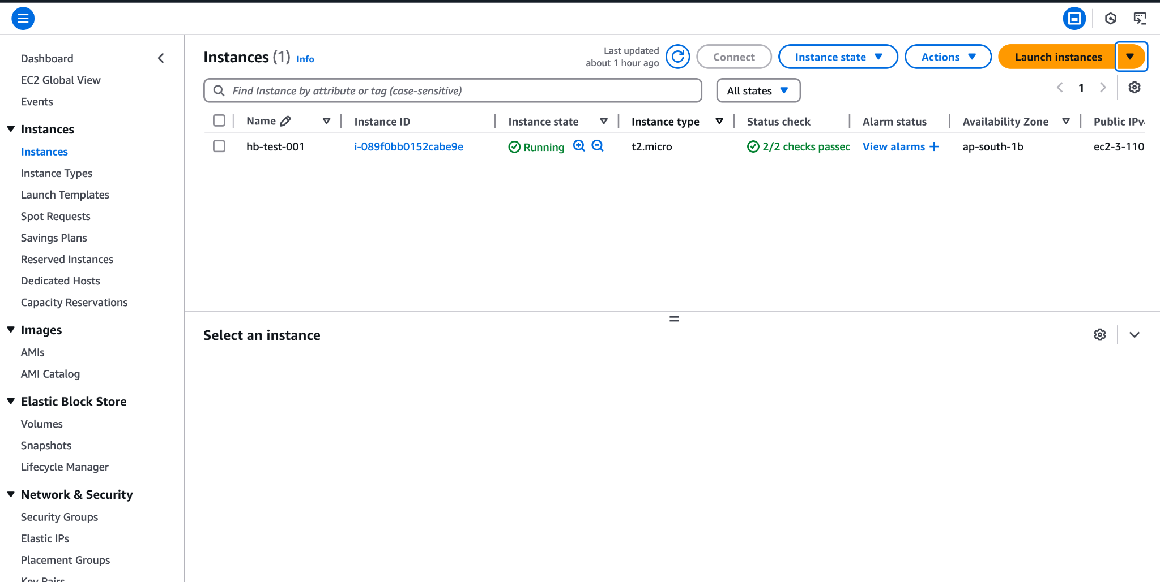

**3. Connect to EC2 using Command line and Create user and group**

1. Go to EC2 Home Page after logging into AWS
2. Click on the EC2 instance you want to use to connect via command line as shown below

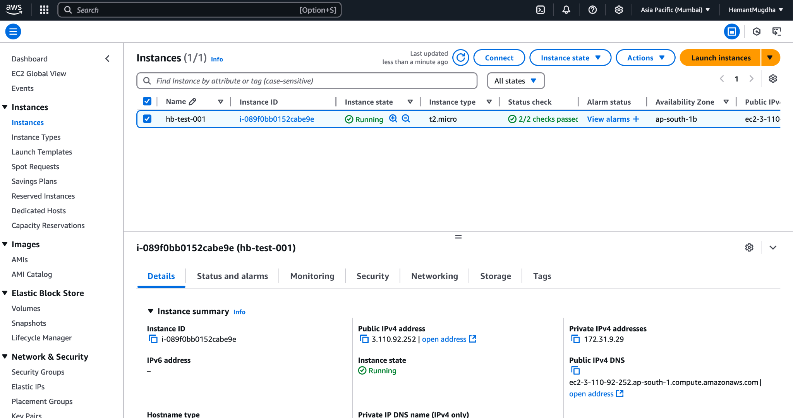

1. Select the insurance by clicking the check box before the name
2. You shall see a all the setting of that instance just below the instance list
3. From the Details tab copy the Public IPv4 address and save it somewhere
4. Now open the command line tool you use and switch to the directory where you saved the .PEM file(key pairs of EC2 downloaded in Section 2)
   1. Use **ls -a** command to list out all the directories in the path
   2. Use **cd** command to switch to the directory wherever you have save the PEM file(you might end up using it multiple times)
5. From the command line use the following command in the order they are mentioned and also refer to the screenshot for the usage
   1. Connect to EC2
      1. Format: ssh -i {{keypair_file_name}} ec2-user@public IPV4 address
      2. Actual Usage: ssh -i hb-test-001-ec2-pem.pem ec2-user@65.0.73.25
   2. Creating User from Command Line
      1. Format: aws iam create-user --user-name {{username}}
      2. Actual Usage: aws iam create-user --user-name mhbtest1
   3. Creating User group from Command line
      1. Format: aws iam create-group --group-name {{groupname}}
      2. Actual Usage: aws iam create-group --group-name test-group-ec2
   4. Adding User to the group from Command line
      1. Format: aws iam add-user-to-group –username {{username}} –group-name {{groupname}}
      2. Actual Usage: aws iam add-user-to-group –username mhbtest1 –group-name test-group-ec2
   5. Screenshot of usage

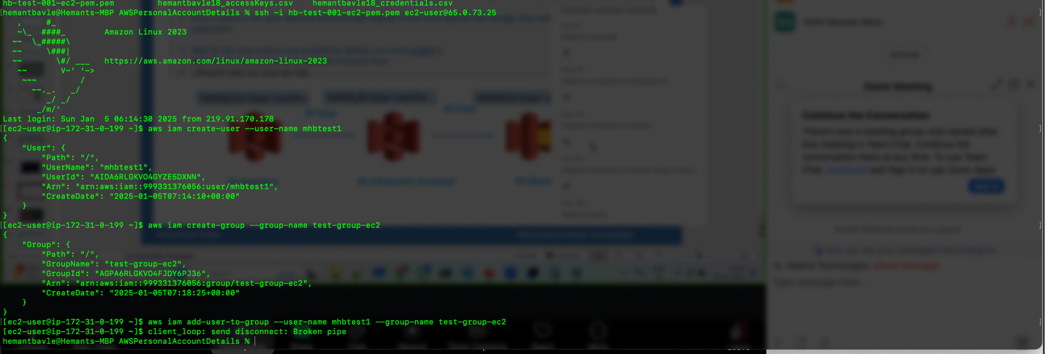

**4. Terminating an EC2 Instance**

1. Login and Open EC2 Home page as shown below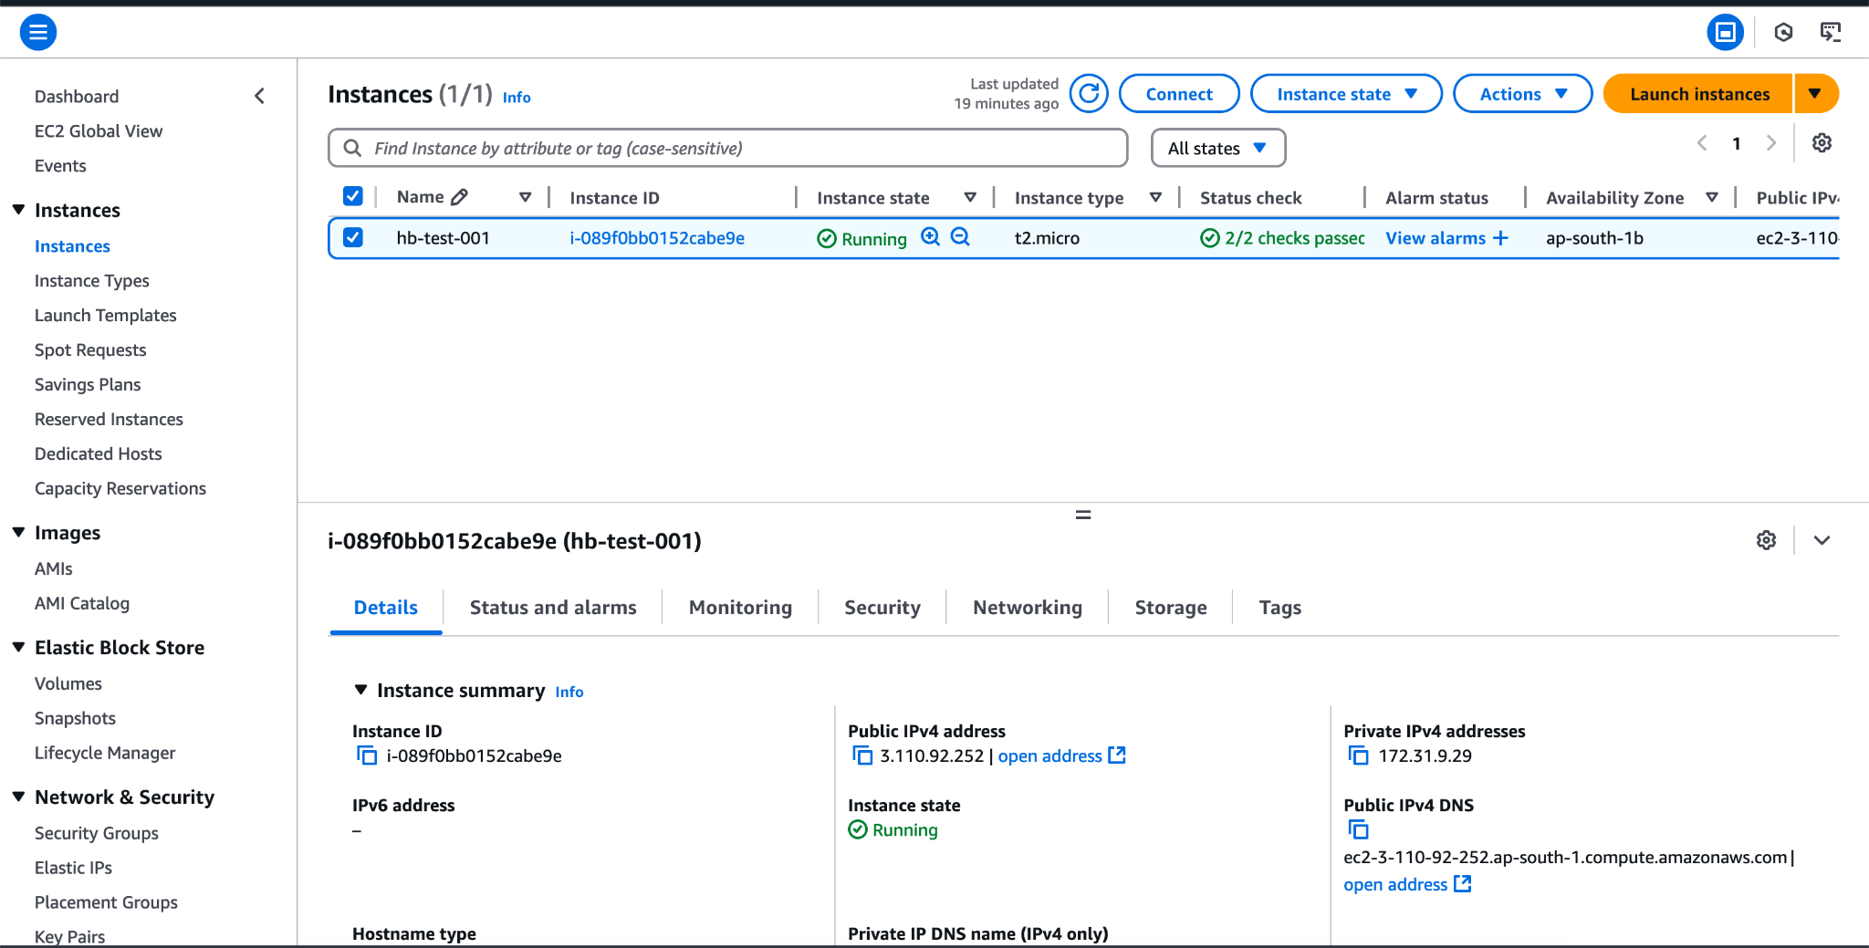
2. Select the instance from the list > Click on instance state dropdown 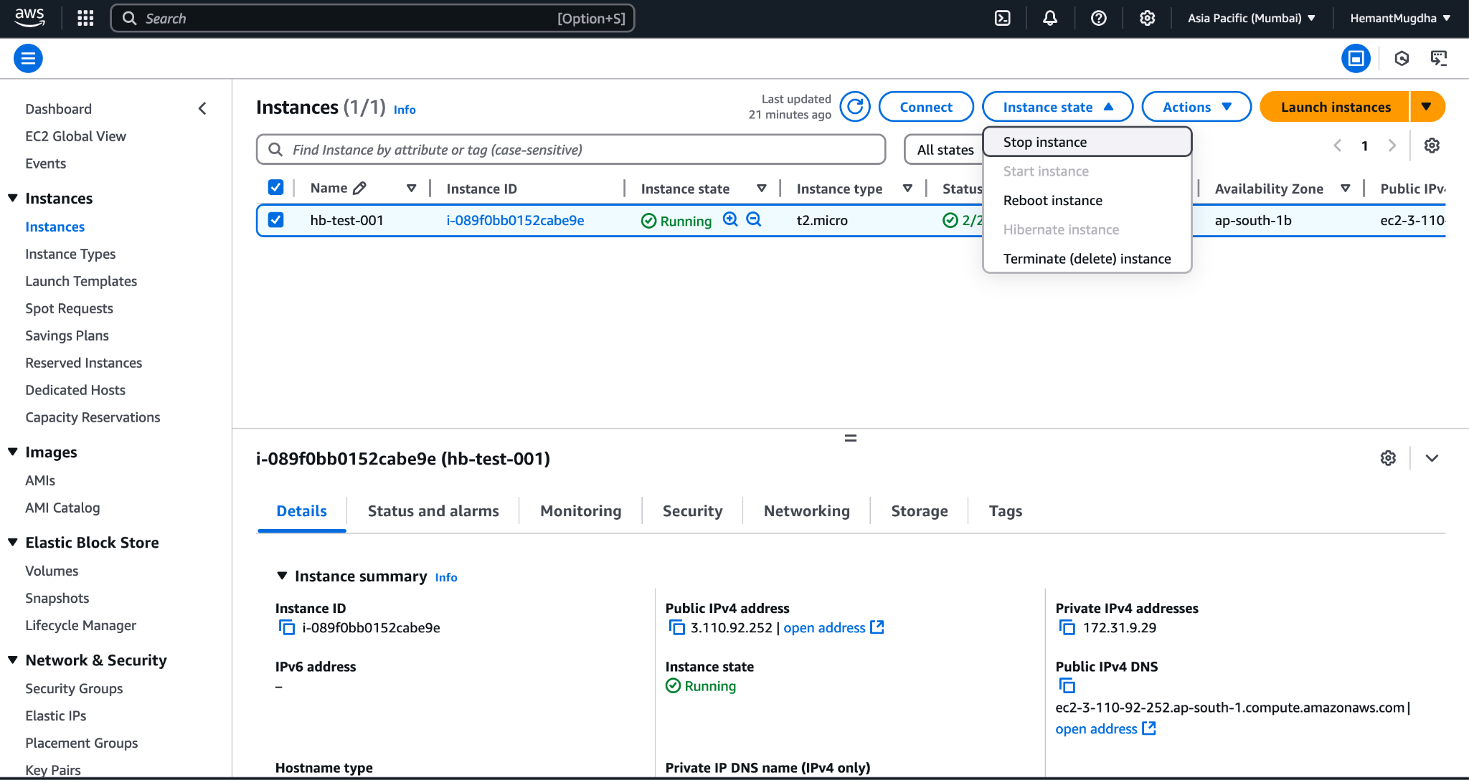
3. Click on Stop Instance and you will see a similar screen instance state changed to stopped for the selected instance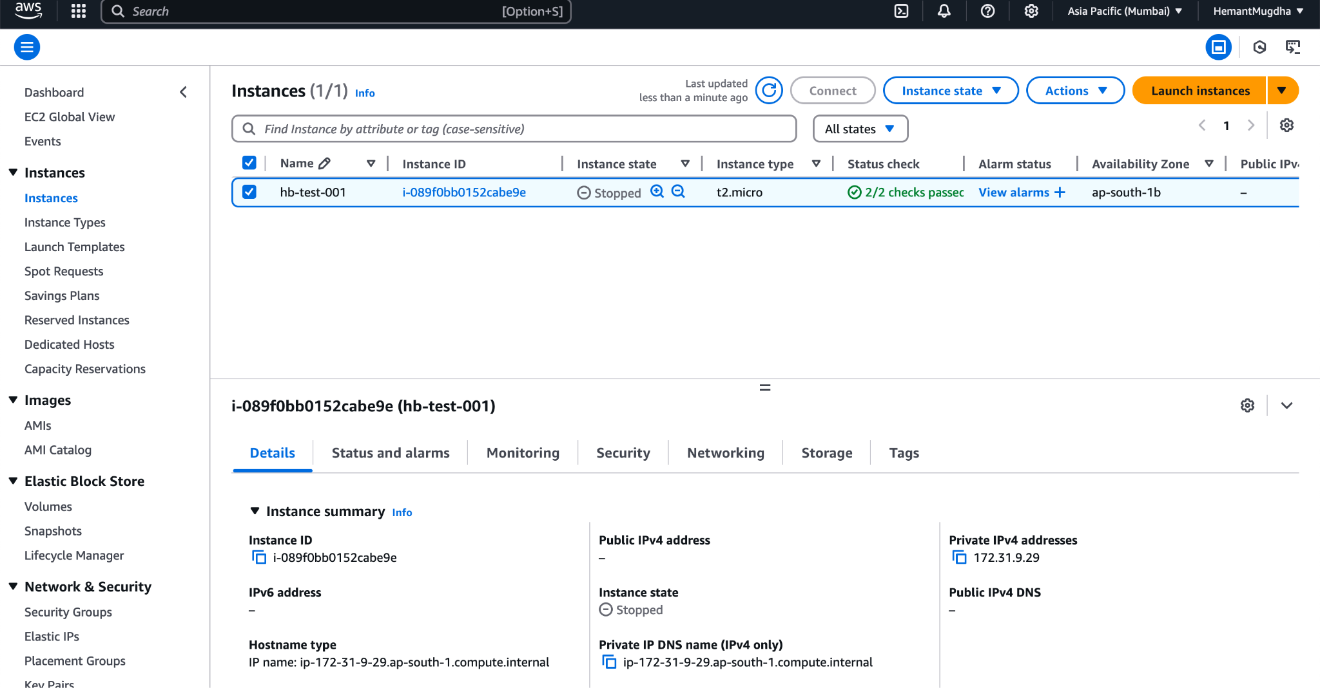
4. Click on Instance State again like Step 2, and click on Stop Instance and you will see the screens as shown below in the screen shot.

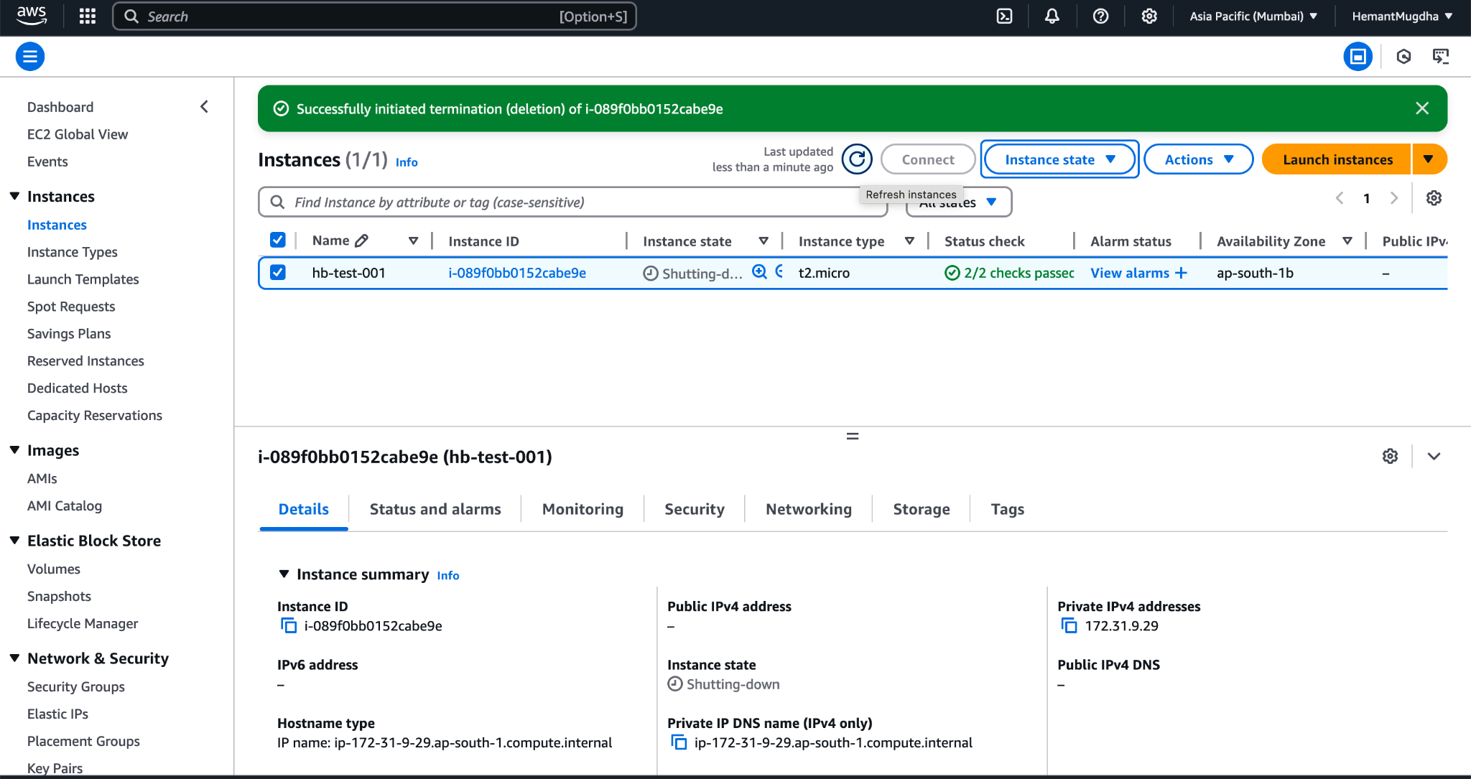

1. Click on search bar > Type Security Group > Delete the Security group as well that was created during instance creation else it might get reflected in your billing.

**3. CREATING A CUSTOM ROLE IN IAM**

1. **Using AWS Service**
2. Login into AWS Console. Based on your history of using the service, you can see the options to open different services. You can also use the search bar at the top to look for IAM service and then click on it to open it’s home page.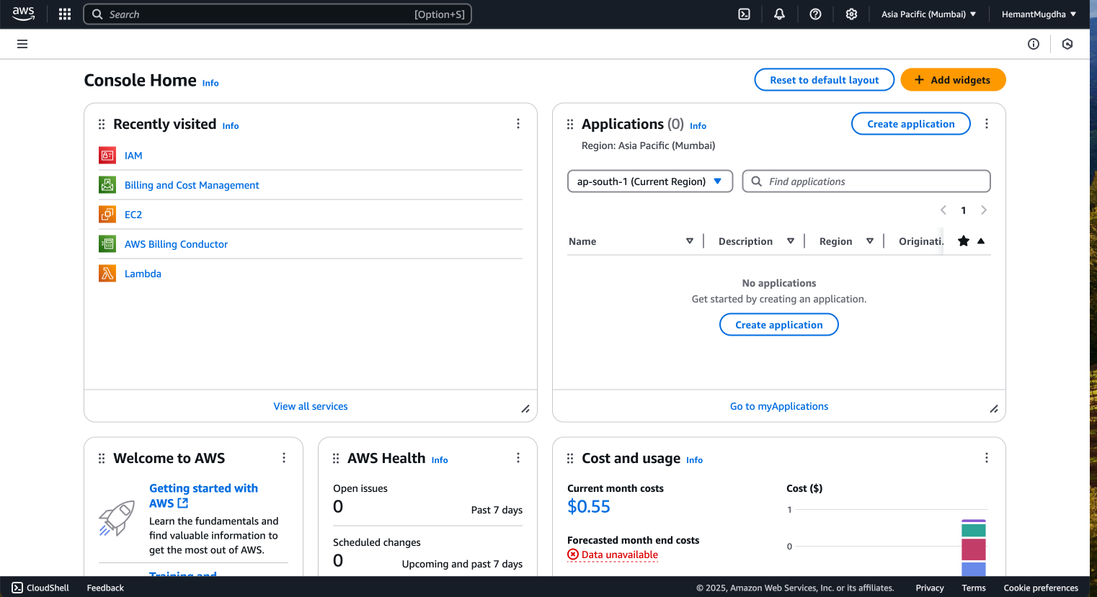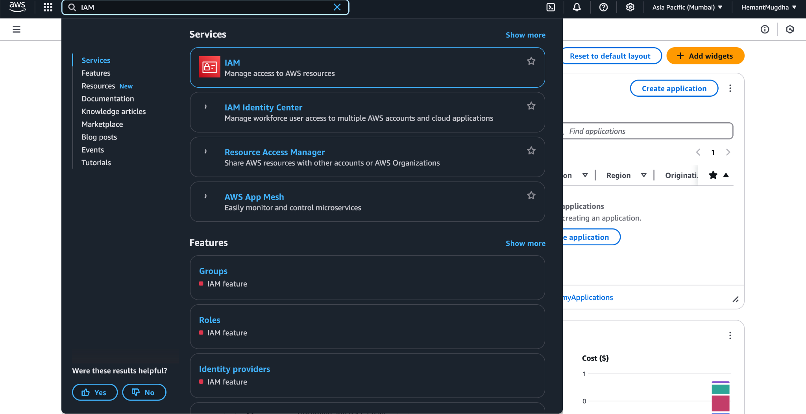
3. Click On IAM. You will land on the screen similar to below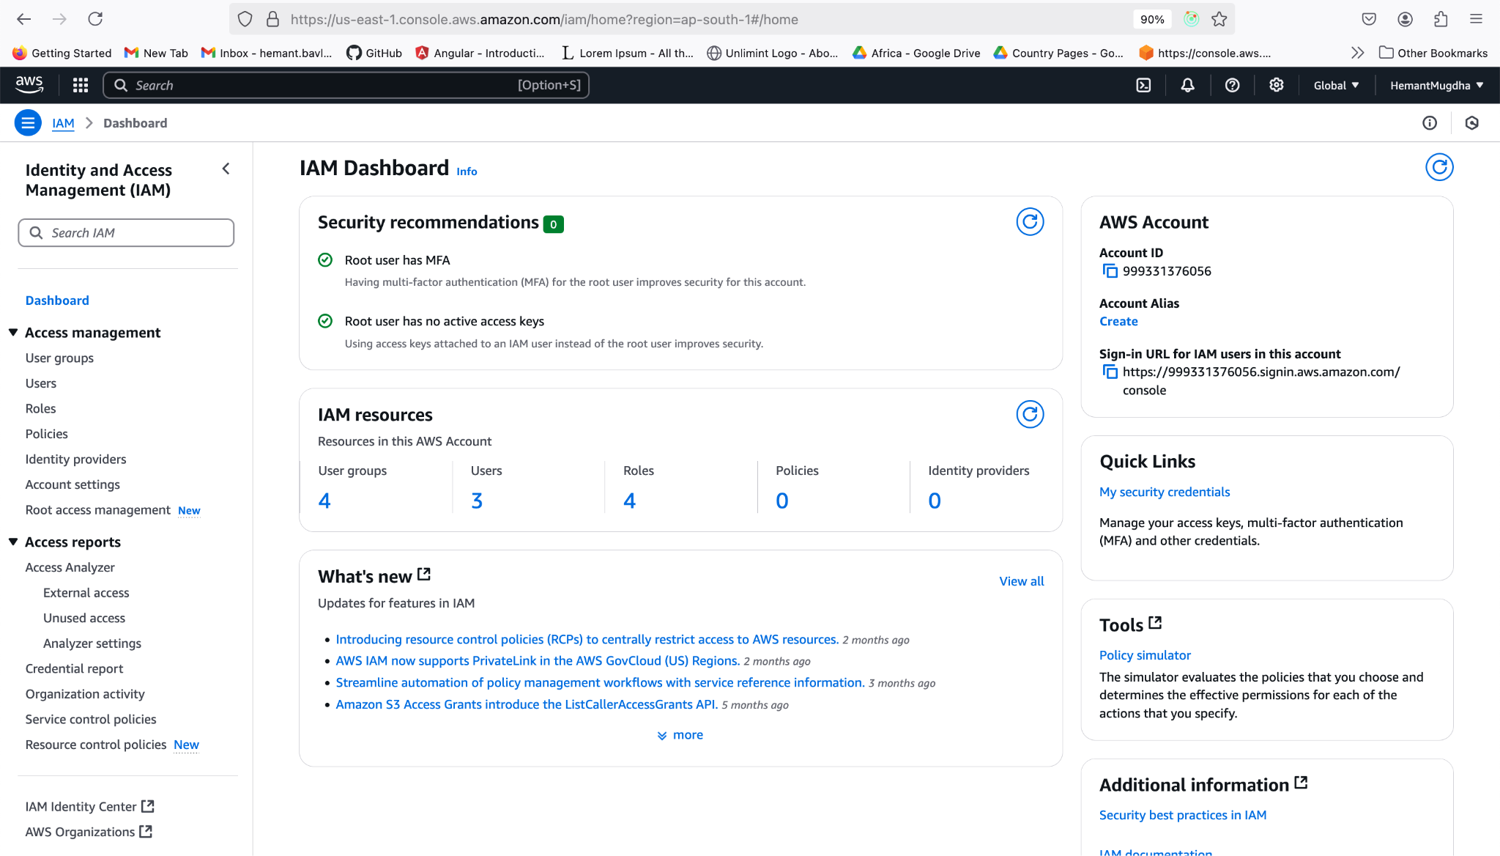
4. Click on the Roles menu as highlighted in blue on the left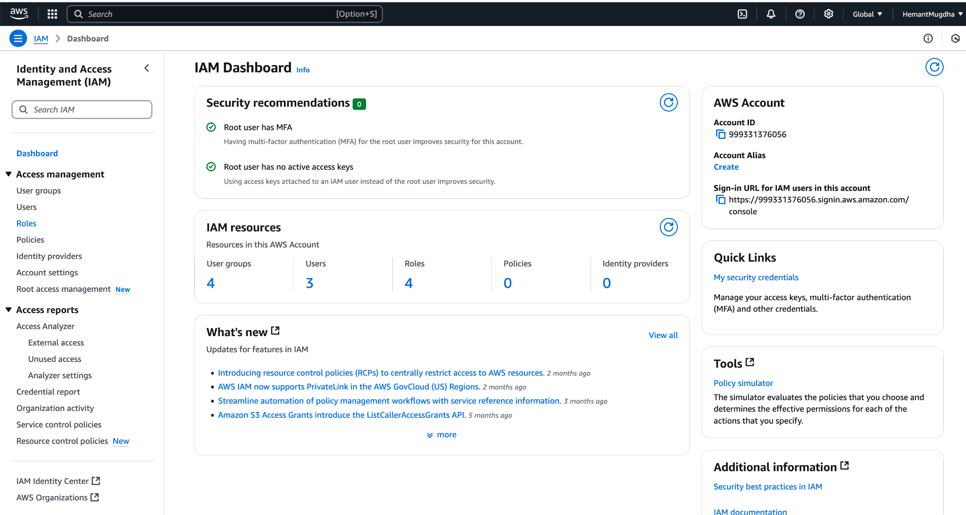
5. If you have some roles already created, then the landing page will look like below.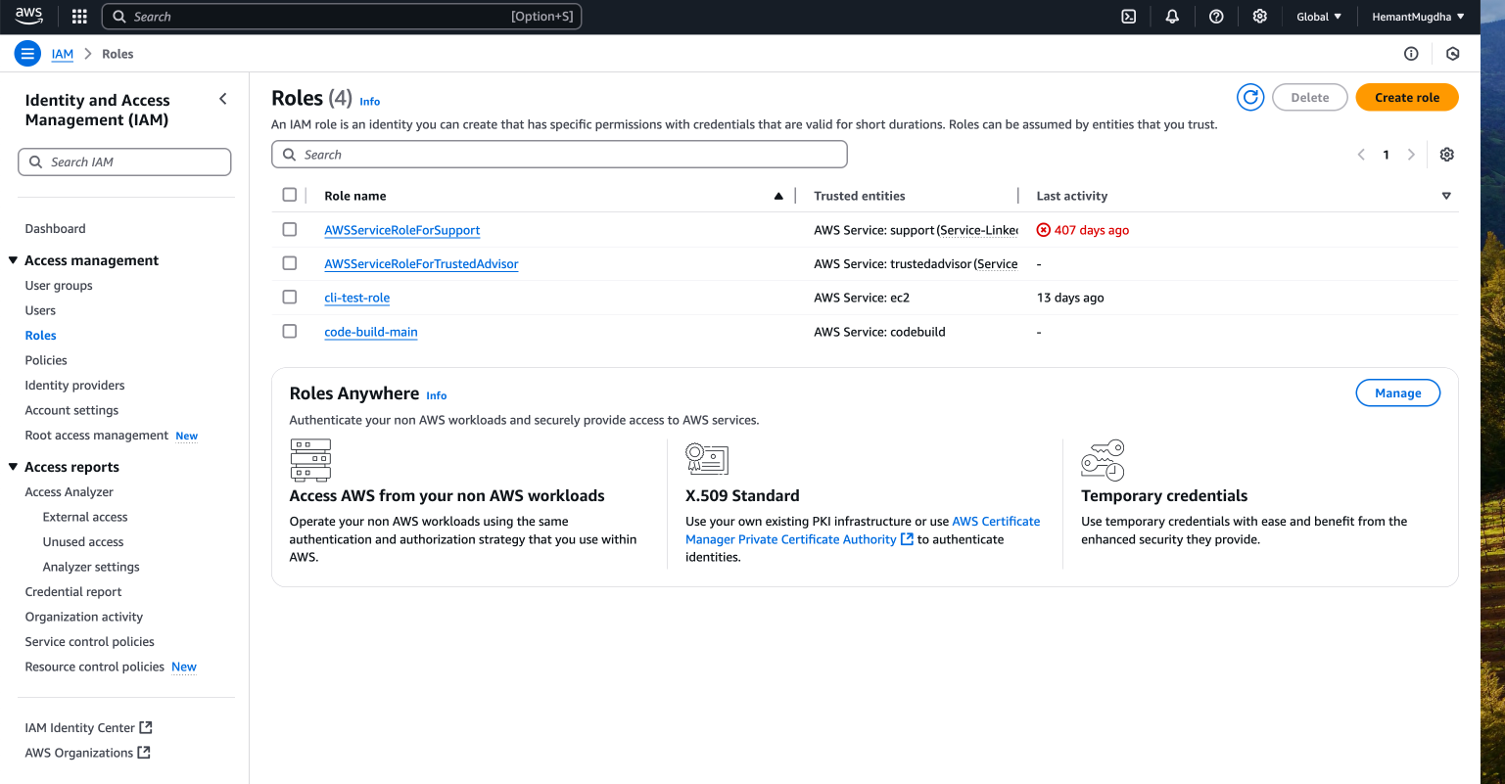
6. To create a new role, click on Create Role button.
7. On clicking the Create Role button, you shall see the following screen.We will work on creating a role, which can be used by an AWS’s service itself.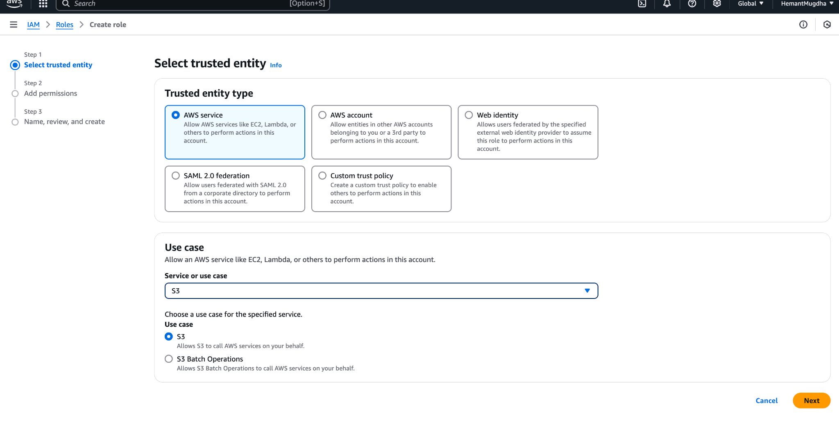
8. On clicking next button in Step 6 above, you can see the following window. Select a policy > Click next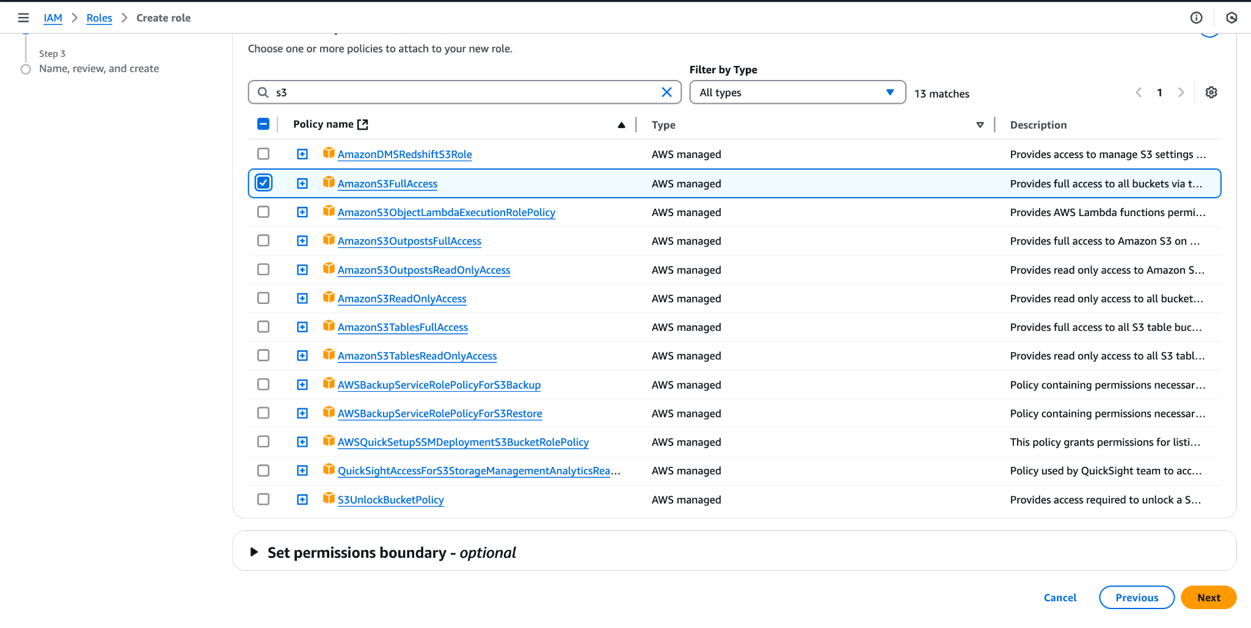
9. On clicking next in the previous step you can see the following screen with JSON of the policy and fields to provide Role name and description.Scroll down and click on **Create Role** button 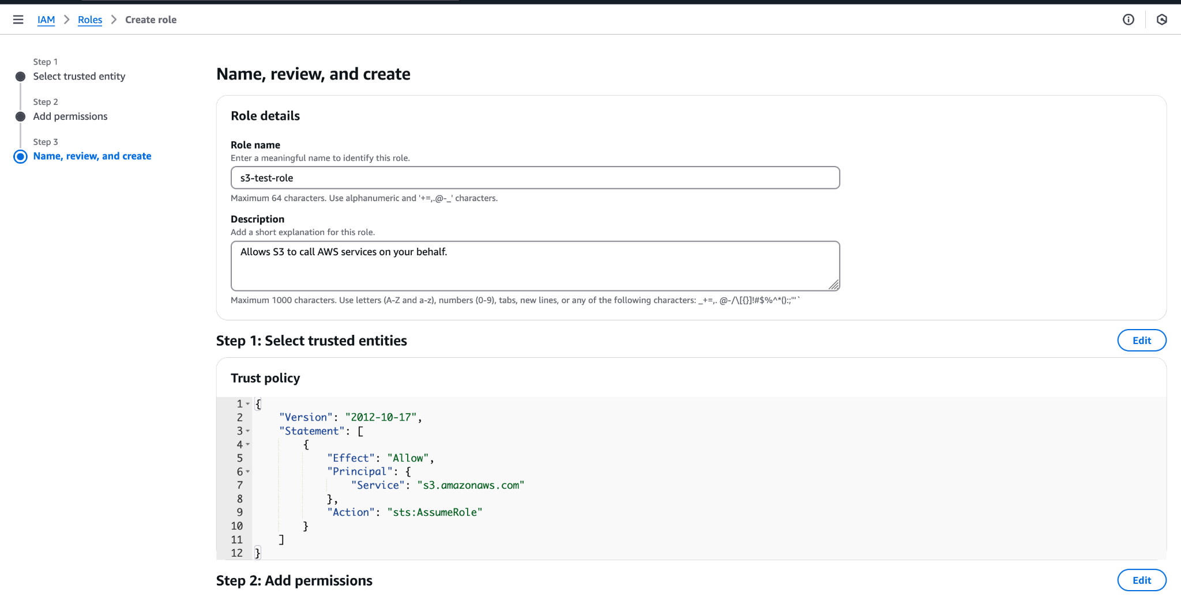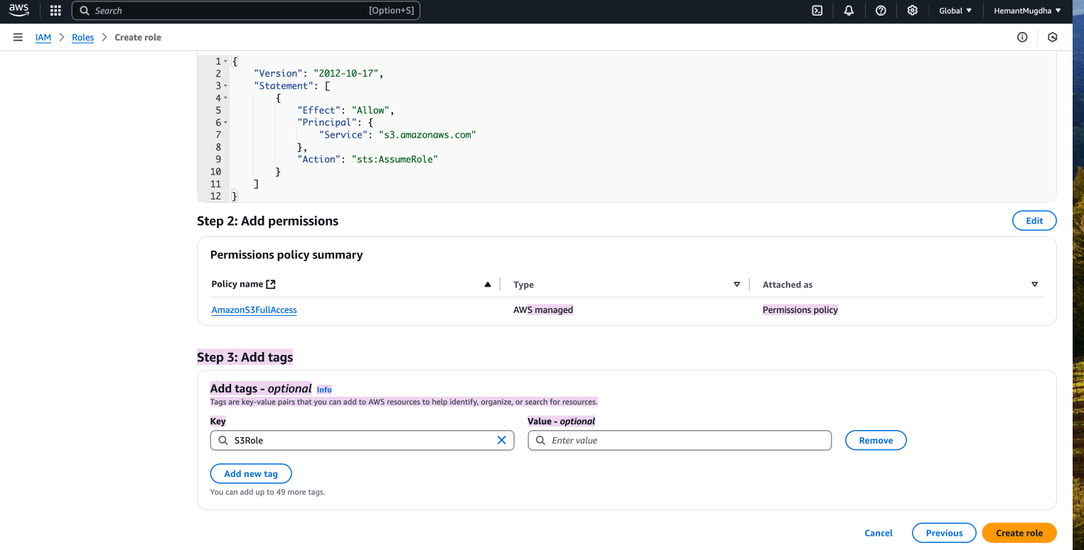
10. Once a role is successfully created, there will be a green colored notification at the top will show up as show below: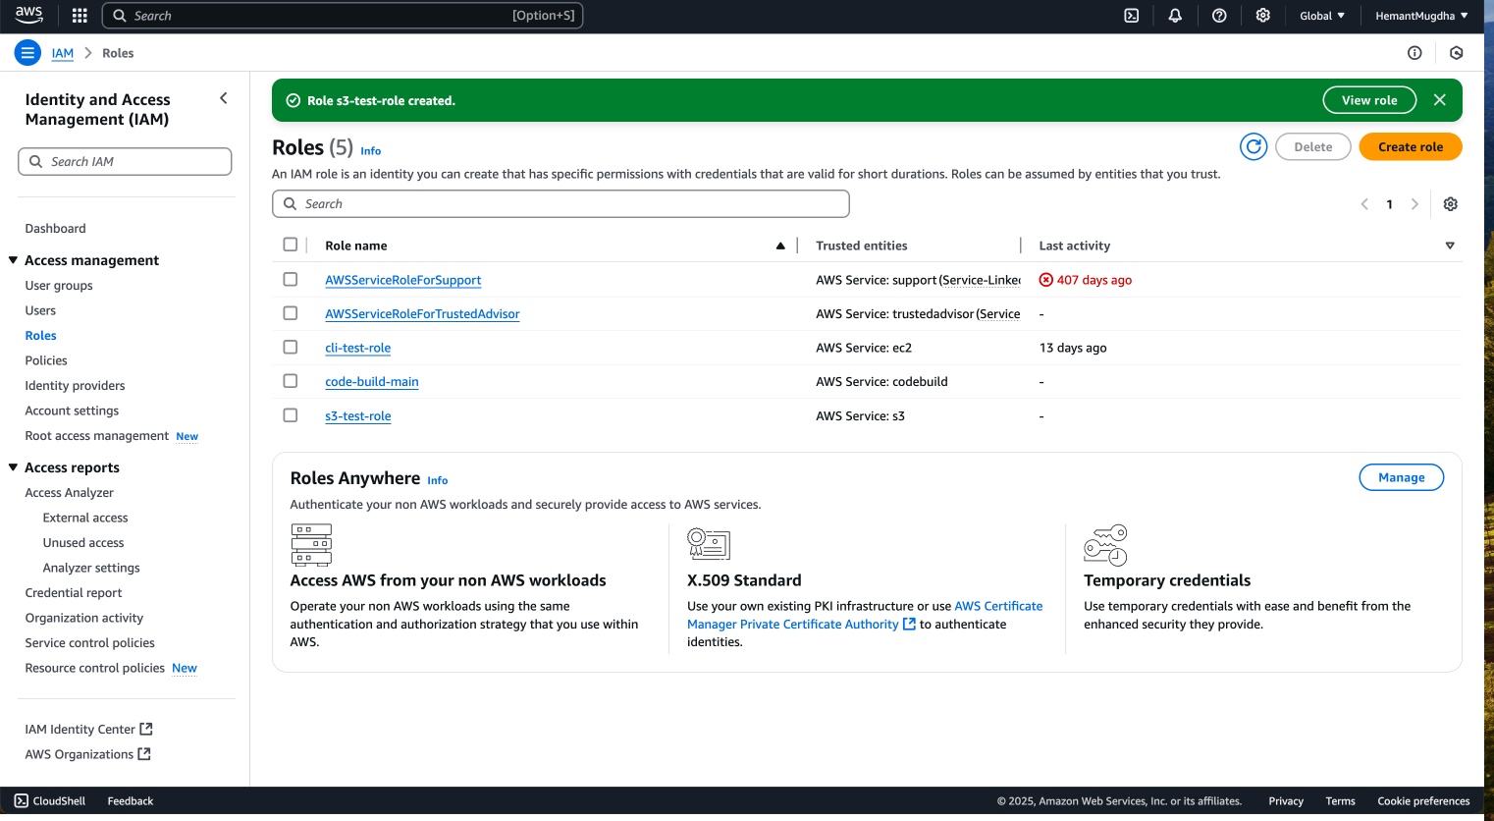
11. You can select a role and click on it to open the role details as shown in screenshots below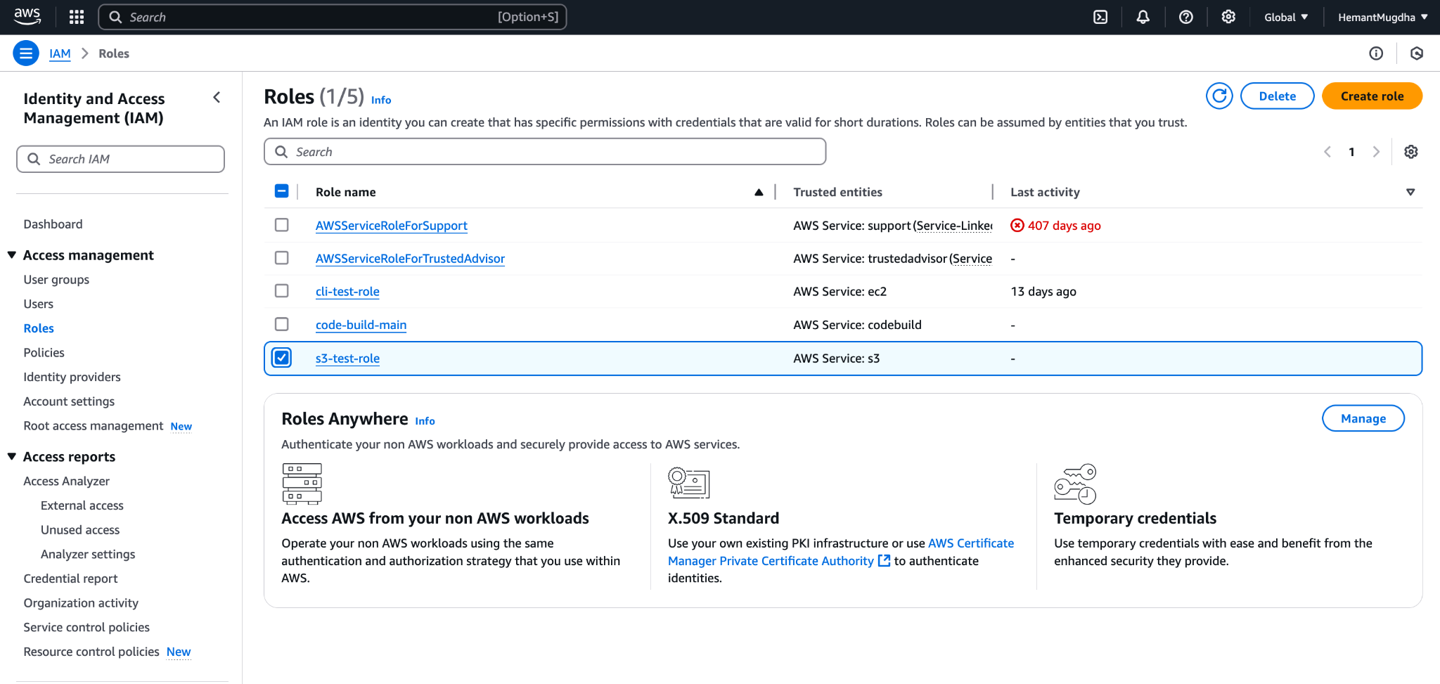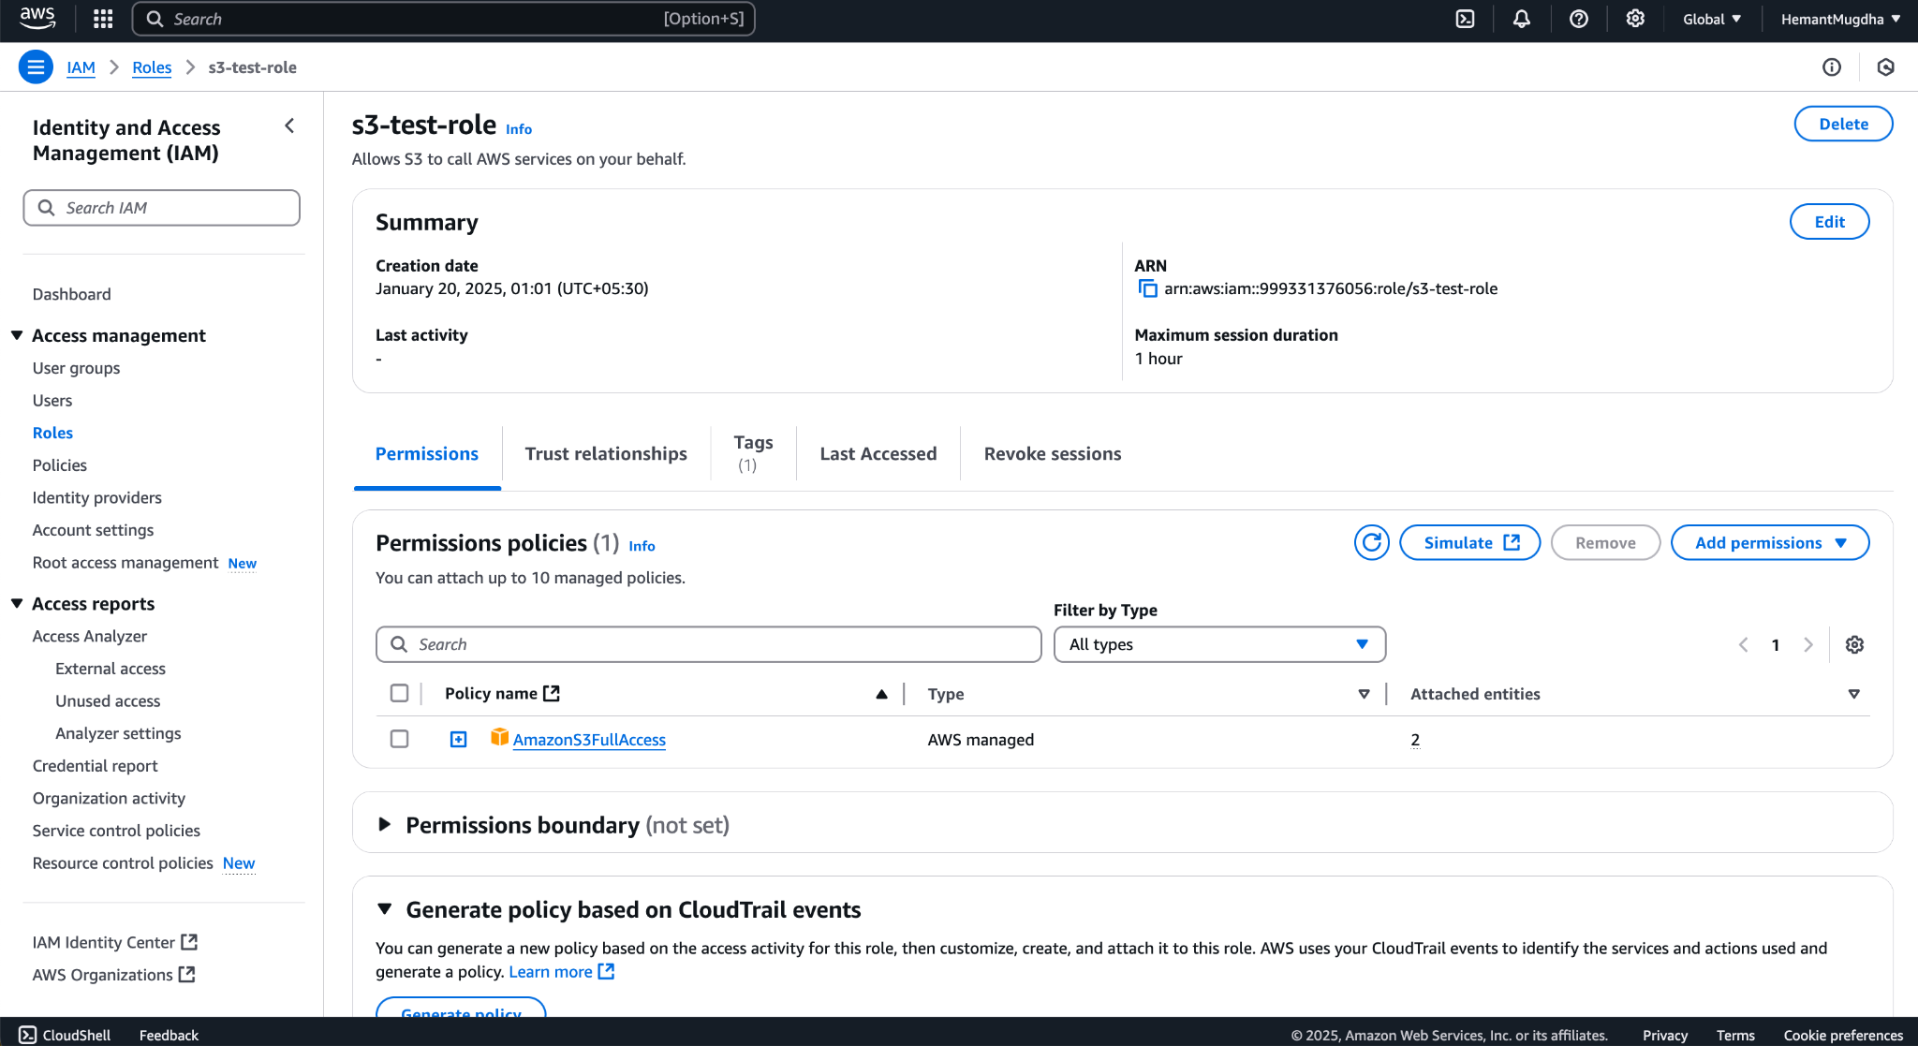

**B. USING AWS ACCOUNT**

1. Login into AWS Console. Based on your history of using the service, you can see the options to open different services. You can also use the search bar at the top to look for IAM service and then click on it to open it’s home page.
2. Click On IAM. You will land on the screen similar to below
3. Click on the Roles menu as highlighted in blue on the left
4. If you have some roles already created, then the landing page will look like below.
5. To create a new role, click on Create Role button.
6. On clicking Create Role, screen shown as below shows up, choose AWS Account option and select this Account in “An AWS account” section. 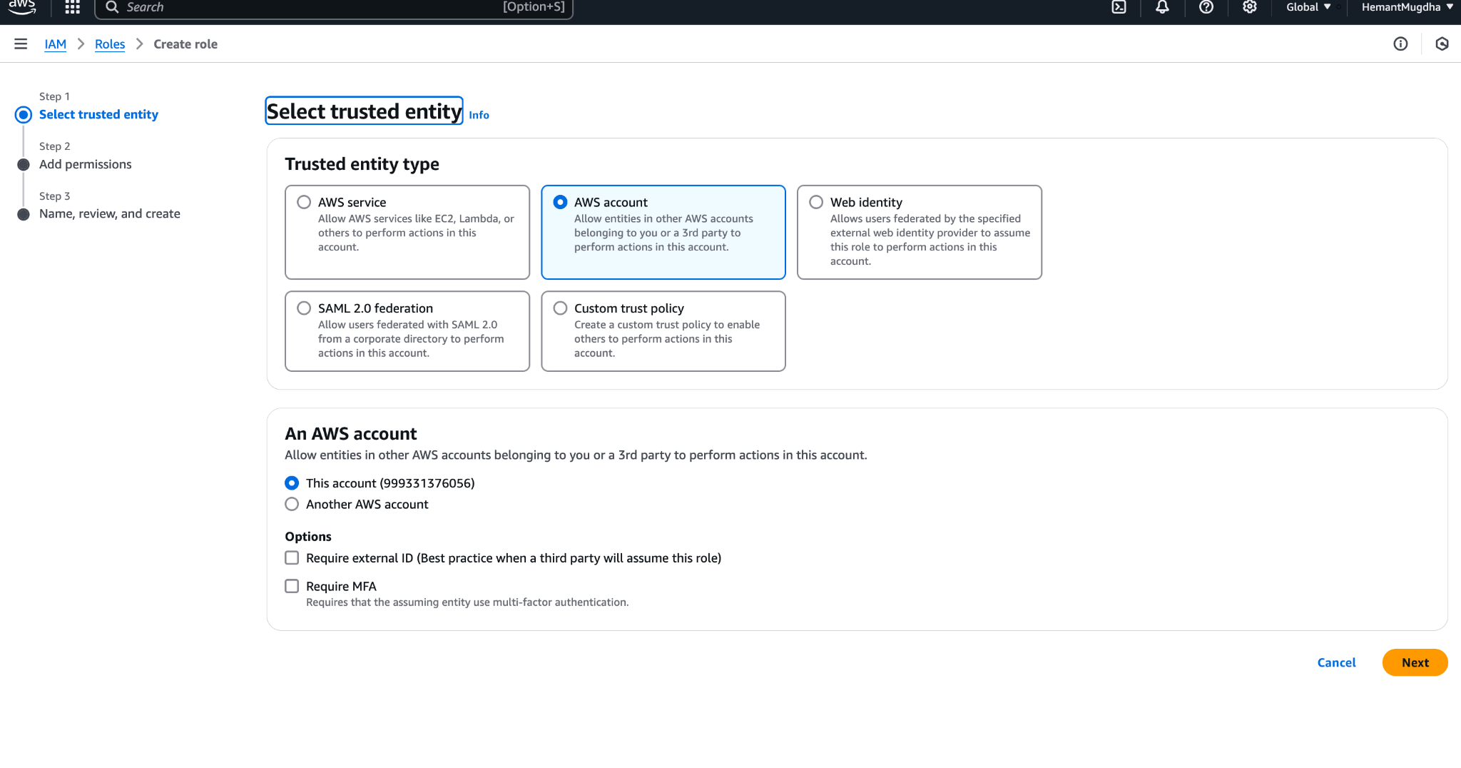
7. To add permission to the role, click next in Step 6 and below screen shows up. Choose the set of permission you want to allow for the role. Click Next after choosing the required permissions.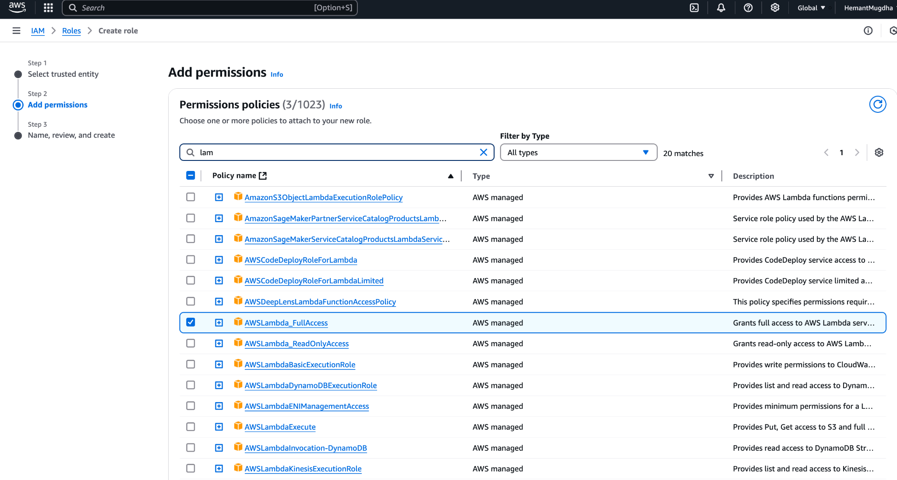
8. Provide details like role name, tags etc as shown in the screen below and click “Create Role”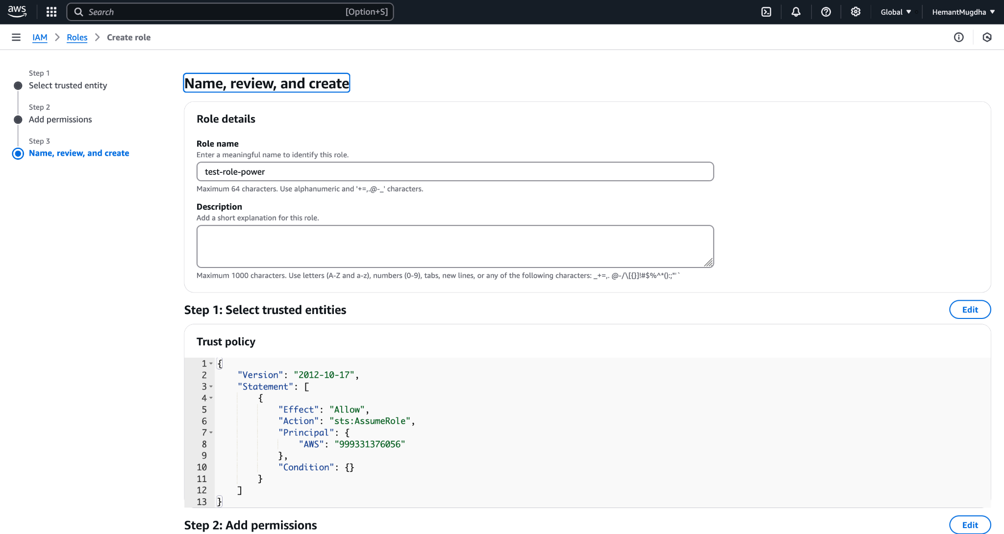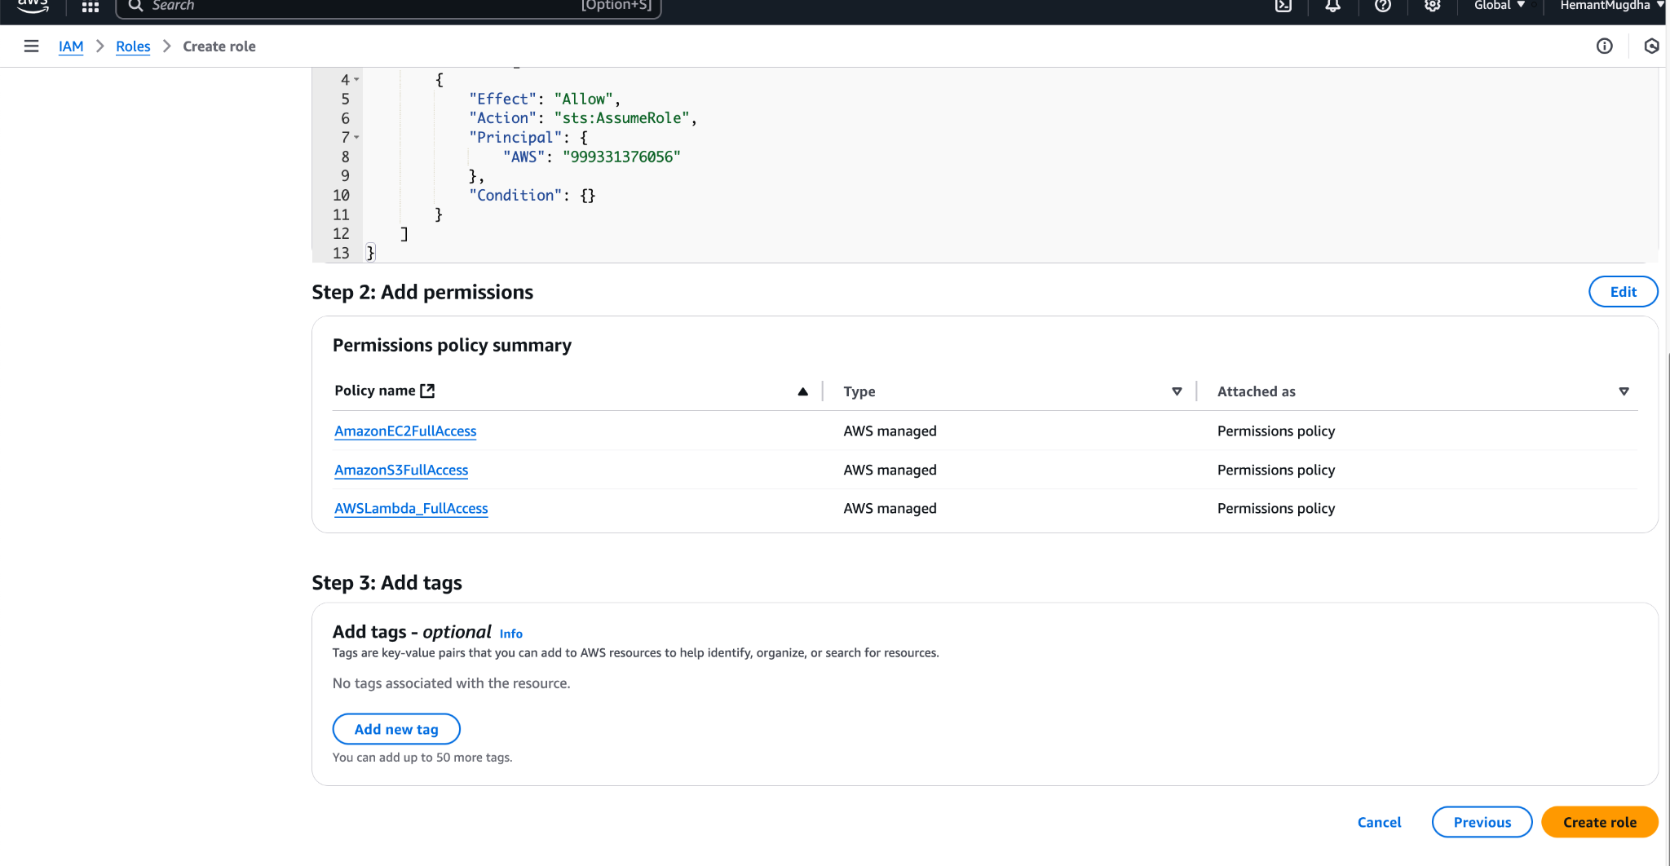
9. The confirmation screen of successful role creation is shown below